Chapter 5, Problem 9.

Determine v_{o} for each of the op amp circuits in Fig. 5.48.
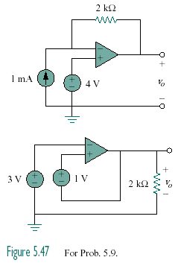
+
–

Figure 5.48
For Prob. 5.9.

